Carbon Dioxide Emission in the Atmosphere and its
Fixation by Metal Complexes
Salah S. Massoud

Department of Chemistry, University of Louisiana at Lafayette, Lafayette, LA, USA

The chemical fixation may lead to certain devices that can eliminate the CO₂ present in the air and hence controlling its concentration and reducing the environmental problems due to the greenhouse effect and global warming. This can be achieved by designing “inexpensive inorganic molecules” that can catalyze the atmospheric CO₂ fixation. A number of simple N-donor ligands and multi-dentate Schiff bases containing two or more N-atoms, phenolic and alkoxy groups are used to synthesize a series of 3d (M(II) = Cu, Ni, Zn) and 4f lanthanides complexes (Ln(III)). The incorporation of Ln(III) ion into the skeleton of 3d complexes increases the affinity of the compounds for CO₂ fixation into the Ln(III) pocket. The resulting bridged-carbonato complexes are not only interesting from the structural and geometrical points of views, but also may result in the discovery of interesting Single Molecular Magnets (SMM’s) which can be used to increase the memory elements of the computers. Recent developments concerning synthesis and structure characterization of different heteronuclear 3d-4f bridged-carbonato compounds, magnetic properties and their potential applications will be addressed.

Biography

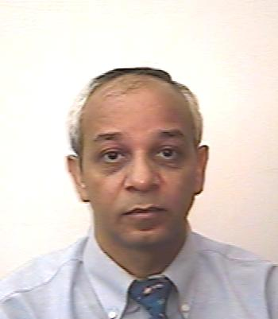
Salah Massoud received his B.Sc and M.Sc from Alexandria University, Egypt and Ph.D. from Boston University. He has postdoctors at Basel University (Switzerland), and University of Alberta (Edmonton, Canada). He had been visiting professor at Boston, Kuwait, Ohio and Houston Universities. He has published more than 140 papers in reputed and peer-reviewed journals, more than 60 presentations in National and International Meetings and he has been serving in the Editorial board committees in a number of journals (Magnetochemistry Journal, Journals of Advances in Chemistry, Modern Chemistry and Applications (JMCA), Dataset Papers in Materials Science).

He joined the Chemistry Department at UL Lafayette in 2002 and since then he mentored more than 80 students in undergraduate research courses. His research interest is focused on bioinorganic chemistry and material sciences. In addition to his collaboration with most colleagues in the Chemistry Department at UL Lafayette, he has very active international collaboration with colleagues at Germany, Austria, Spain, Czech Republic and Japan.

